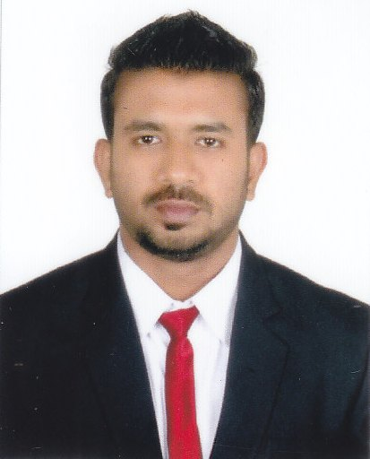

Sheikh Hassan Sayeed Mohammed  
(+91)9764198989  
shaikhnafiyaz@gmail.com

**Objective:**To obtain a position where I can utilize my knowledge and management skills to maximize profits of the firm.

**Professional Qualification:**

* PGDBA from Adarsha Institute of Management in Banking & Finance, Goa University (pursuing 2013-2014)

**Academic Qualification:**

* Bachelor of Commerce from Government college of Arts, Science & Commerce Sanquelim Goa in financial Accounting, Auditing and Taxation (2013).
* Higher secondary school from Government higher secondary school Valpoi, Goa

(2010).

* Secondary school from Unity high school valpoi , Goa (2008).

**Skills**

* MS Word.

**Hobbies**

* Working out in the gym, cooking, dancing, listening music.

**Academic project**

* Project on feasibility study to start a multiplex in Sanquelim town.

**Internship**

* Schneider Electric India Ltd, Verna, Goa.
  + Role: Management Trainee
  + Duration: 11 weeks(28th April – 12th July)
  + Responsibility: worked under each department to complete the project assigned.

**Achievements**

* Felicitated by “Popular Front of India” for scoring distinction in B.com.
* Awarded for top 10 outgoing students from college.
* Won Bronze medal at inter college competition for power lifting and weight lifting.

**Extra-curricular activities:**

* Participated in various inter college competition.
* Member of organising committee for the events “Razzle Dazzle” & “Puzzle Mania”.
* NSS volunteer.
* Member of Phoenix Club.

**Personal detail:**

* DOB: 13 January 1992
* Address: H.no-06, Nanus, Valpoi, Goa

403506

* Languages known: English, Konkani, Hindi, Marathi, Urdu.

**Declaration:**

* I hereby declare that the information given is true to the best of my knowledge and belief.